CONTEÚDO PROGRAMÁTICO

2° ANO
Avaliações 1 - VALOR: 3.0 PONTOS - 1ºTRIMESTRE – 2020
Datas | Avaliações
27/3 | Inglês
Conteúdo da Avaliação 1 - 1° TRIMESTRE
English
Natural social science 1
Unit 1 – All about me and school (Page 4 to 15)
- Whats your name and how old are you?
- Days of the week; Monday to Sunday.
- Are you a boy or a girl?
- Places in the school; Classroom, library, dinning room, gym, playground and toilets.
- What do you do at school? I read in the library, i run in the gym, i play in the playground (Read, write, draw, sing, think and speak english)
- People at school; teacher, cook, caretaker.
- We study different subjects at school; whats your favorite? Music, art, science, p.e, english.
- Unit 2 – My sense (Page 16 to 21)
- Five sense and body parts; see, hear, smell, touch, ears* eyes, nose, tongue, hands*
- With my eyes i can see... ears i can hear...
- I can hear sounds with my ears; like birds, music (QUIET/ LOUD)
- Good smell and bad smell.
- I can taste; sweet, salty, sour and bitter.
- I can touch; hard, soft, smooth and rough
- I can see; apples, bananas, different colors.
So happy to be with you.
Don’t forget to study!

CONTEÚDO PROGRAMÁTICO

2° ANO
Avaliações 2 - VALOR: 5.0 PONTOS - 1ºTRIMESTRE – 2020

Datas | Avaliações
15/05 | Inglês
Conteúdo da Avaliação 2 - 1° Trimestre
English
Natural social science 1
Unit 3 – My body (Page 26 to 35)
- Parts of the body; hair, mouth, arm, leg, feet, head, finger and toe.
- My body has three parts; head, torso and limbs
- My joints; hip, elbow, knee, shoulders, wrist and ankle (Joints helps your body move)
- Feelings; how are you? I am; happy/ sad/ angry.
- Unit 4 – Family members (Page 36 to 45)
- Family members; mother, father, baby, grandmother, grandfather, brother, sister, aunt, uncle and cousing. How many brothers and sisters you’ve got? I’ve got...
- Helping at home; tidy up, water the plants, cook the dinner, wash the dishes, make the bed and lay the table.
- Where do you live? I live in a flat/house.
- Rooms in a house; bedroom, living room, bathroom, kitchen.
Unit 5 – Food (Page 45 to 55)
- Types of food; chicken, meat and fish/ Fruit and vegetables
- Differentiate between fruit and vegetables and identify food that is good for you.
- Food from plants and animals.
- My meals; meals of the Day- breakfast, lunch and dinner.
So happy to be with you.
Don’t forget to study!

CONTEÚDO PROGRAMÁTICO

2° ANO
Avaliações 1 - VALOR: 3.0 PONTOS - 2ºTRIMESTRE – 2020

Datas | Avaliações
26/06 | Inglês
Conteúdo da Avaliação 1 - 2° TRIMESTRE
English
Natural social science 1
Unit 6 – Animals (Page 56 to 65)
- Domestic animals; pig, cow, hen, cat, dog, horse, sheep and duck
- Animals babies; kittem. Puppy, chick and piglet. (A kitten is a baby cat)
- Wild animals; snake, elephant, crocodile, monkeys, zebra, Lion...
- Animal habitats; some animals lives on land and some animals lives in the water.
- How do animals move? Walk, fly, swim and Slither
- Living and non-living things.
Unit 7 – Plants (Page 66 to 68)
- Plants and their basic needs; plan, Grass, bush, tree, cactus* flower, fruit, leaves and seed.
- Plants need water, air and sunlight
- Parts of the plants; seeds, roots, stem, leaves.

So happy to be with you.
Don’t forget to study!

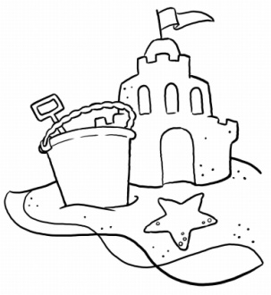

CONTEÚDO PROGRAMÁTICO

2° ANO
Avaliações 2 - VALOR: 5.0 PONTOS - 2ºTRIMESTRE – 2020
Datas | Avaliações
28/8 | Inglês

Conteúdo da Avaliação 2 - 2° TRIMESTRE
English
Natural social science 1
Unit 7 – Plants (Page 69 to 75) REVIEW.
- Plants in my environment; trees, bushes and Grass.
- How plants take in water
- We eat different parts of the plants
- Unit 8 – Water and air (Page 76 to 85)
- Where we find water; sea, snow, waterfall, rain, ice, cloud, river, lake.* There is water in the lake.*
- All living things need water; people, plants and animals.
- Uses of water; to drink, wash, swim, clean, cook...
- Charactristics of water; water has no colour, taste or smell.
- Air as necessary for life.
- Wind is a force that moves things
- The weather; Sunny, cloudy, raining, stormy, snowing, windy and foggy.
So happy to be with you.
Don’t forget to study!

CONTEÚDO PROGRAMÁTICO

2° ANO
Avaliações 1 - VALOR: 3.0 PONTOS - 3º TRIMESTRE – 2020

Datas | Avaliações
02/10 | Inglês

Conteúdo da Avaliação 1 - 3° TRIMESTRE
English
Natural social science 1
Unit 9 – Places (Page 85 to 95)
- Main features of a neighbourhood; park, chemist, Baker, church, post Office, supermarket,bank, library, school.
- People Who help us and where they work; ex: A teacher teaches childlren.
- What do you want to be? I want to be....
- Transport; car, bus, plane, helicopter, boat and bike

- Unit 10 – Landscapes (Page 96 to 105)
- Differences between inland and costal landscapes; mountain, cliffs, Forest, sand, seaweed, lake, sea and plain. Where do you go for your holidays?
- What do you like to do? I like (riding a bike).
- Safety precautions on Holiday; helmet, armbands and life jacket.
- Natural and man-made features of landscapes.
So happy to be with you.
Don’t forget to study!

CONTEÚDO PROGRAMÁTICO

2° ANO
Avaliações 2 - VALOR: 5.0 PONTOS - 3ºTRIMESTRE – 2020

Datas | Avaliações
23/11 | Inglês

Conteúdo da Avaliação 2 - 3° TRIMESTRE
English
Natural social science 1
Unit 11 – The sun (Page 106 to 115)
- Elements seen in the Sky; Sun, moon, stars, planet
- Day and night; activities associated with Day and night/ I go to school in the Day.
- The Sun gives heat and light. The Sun is round and also a star.
- The seaons; Summer, spring, winter and autumn.
- Months of the year.

- Unit 12 – In the kitchen. (Page 94 to 21)
- Types of materials; metal, plastic, Wood, paper, glass and fabric
- What things are made of. Ex; the table is made of Wood.
- Properties os materials; rigid, bendy, hard, soft, rough and smooth.
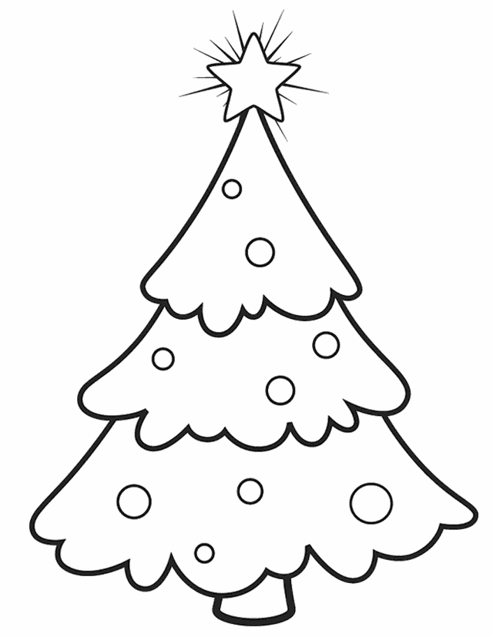
- Transparent and opaque materials
- Some items that can be recycled. Ex; paper goes in the (blue) Bin.

Happy Holidays! ;)

