CONTEÚDO PROGRAMÁTICO

1° ANO
Avaliação 1 - 1º TRIMESTRE - 2020
Avaliação assistida
Datas | Avaliações
27/03 | Inglês
Conteúdo da Avaliação 1 - 1° TRIMESTRE
English
Doodle Town 3
Unit 1 – At school (Page 2 to 11)
- Math: Numbers - from 1 to 10
- Animals – cat, Lion, turtle
- Read the sentence – What are you doing? Ex; i am kicking the Ball
- Colors: Orange and Green.
- Science: Whats the wather like today? Today is sunny, rainy, claudy or windy.
- Phonics: A, C, T, L, P

- Unit 2 – Fun and game (Page 12 to 21)
- Math: Lets add
- What do you like to do? I like to stretch, spin, hop, clap, wave or wiggle
- Colors: Blue, purple, red and yellow.
- Phonics: H, S, I, K, B
So happy to be with you.
Don’t forget to study!

CONTEÚDO PROGRAMÁTICO

1° ANO
Avaliação 2 - 1º TRIMESTRE - 2020
Avaliação assistida
Datas | Avaliações
15/05 | Inglês
Conteúdo da Avaliação 2 - 1° Trimestre
English
Doodle Town 3
Unit 3 – Clothes (Page 22 to 31)
- Math: Graph and numbers from 1 to 20 (count buttons)
- Read the sentence - What do you wear at school? Ex: I wear my (uniform)
- Size of items; TOO BIG AND TOO SMALL
- The mitten and colors; Pink crayons, purple crayons, Green crayons.
- Phonics: M, G, F, SH

- Unit 4 – Farm fun (Page 32 to 41)
- Math: Count to 15; do additions and talk about how many animals are there.
- There are / There is
- Comparing sizes; Big and small
- Phonics: E, R, D, N
- Animals from the farm; hen, chicks, horse, puppy.
- Read the sentence; What is your favorite animals? My favorite animal is...
So happy to be with you.
Don’t forget to study!
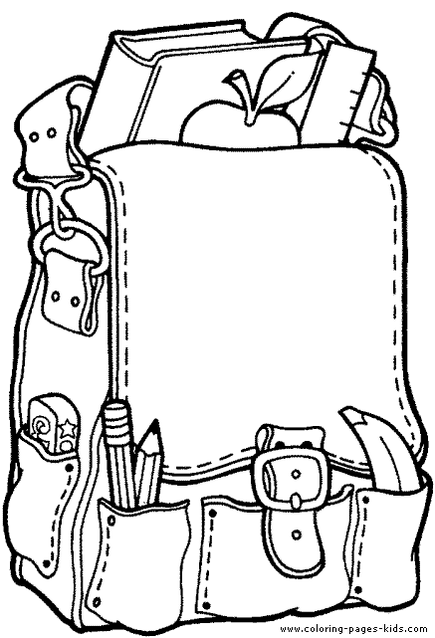

CONTEÚDO PROGRAMÁTICO

1° ANO
Avaliação 1 - 2º TRIMESTRE - 2020
Avaliação assistida
Datas | Avaliações
26/06 | Inglês

Conteúdo da Avaliação 1 - 2° TRIMESTRE
English
Doodle Town 3
Unit 5 – Our amazing body (Page 42 to 51)
- Math: Count to 30 by fives
- Body parts; Head, shoulders, back, feet, chin, cheeks, eyes, nose, legs, knee, toe.
- Read the sentence – What can it do with its tongue? I can taste
- Giraffe has a long tongue

So happy to be with you.
Don’t forget to study!

CONTEÚDO PROGRAMÁTICO

1° ANO
Avaliação 2 - 2º TRIMESTRE - 2020
Avaliação assistida
Datas | Avaliações
28/08 | Inglês

Conteúdo da Avaliação 2 - 2° TRIMESTRE
English
Doodle Town 3
Unit 5 – Our amazing body (Page 42 to 51) REVIEW.
- Math: Count to 30 by fives
- Body parts; Head, shoulders, back, feet, chin, cheeks, eyes, nose, legs, knee, toe.
- Read the sentence – What can it do with its tongue? I can taste
- Giraffe has a long tongue

- Unit 6 – Let’s eat (Page 52 to 63)
- Math: Subtraction; how many are left?
- Breakfast and luch; what do you eat?
- What are you doing? I am (squeezing) the lime / She is (peeling) the banana
- Lets make a smoothies; selection of fruit like bana, limes, strawberries, milk or yogurt.

So happy to be with you.
Don’t forget to study!

CONTEÚDO PROGRAMÁTICO

1° ANO
Avaliação 1- 3º TRIMESTRE - 2020
Avaliação assistida
Datas | Avaliações
02/10 | Inglês

Conteúdo da Avaliação 1 - 3° TRIMESTRE
English
Doodle Town 3
Unit 7 – At the beach (Page 64 to 73)
- Math: Numbers – count to 50 by tens
- Animals from the sea – fish, crab, whale, shark, octopus and jellyfish
- Sandcastle
- Round and flat
- Sea turtle and how can we help them?

- Unit 8 – On the Go (Page 74 to 83)
- Math: Coun to 1 to 80 by tem; shapes and addition
- Transports; taxi, subway, train, ferry, bus and trolley
- Read the sentence; how do we get to the park? We can take a bus.
- Where is the frog? The frog is on the log.

So happy to be with you.
Don’t forget to study!

CONTEÚDO PROGRAMÁTICO

1° ANO
Avaliação 2 - 3ºTRIMESTRE - 2020
Avaliação assistida
Datas | Avaliações
23/11 | Inglês

Conteúdo da Avaliação 2 - 3° TRIMESTRE
English
Doodle Town 3
Unit 9 – Celebrations (Page 84 to 93)
- Math: Numbers - from 1 to 100
- When thing are; this afternoon, today, tomorrow and tonight.
- Days of the week
- Colors of the drum; Brown, yellow, purple, grey.
- Alphabet
- Birthday party and how are you today? I am happy.

- Unit 10 – The name of the tree. (Page 94 to 21)
- Math: review numbers 1-100; count by fives and tens.
- Family members; Mother, father, gramma and grampa.
- Animals from the jungle; zebra, giraffe, Lion and monkey
- Fruits. Bananas, apples and bananas.

Happy Holidays! ;)

